Task 1
Problem: A diver recorded underwater pressures. Which value was the highest?.
Pattern: Maximum Selection
Specification: (link)

In: size∈N, arr∈Z[1..size]
Out: max∈Z
Pre: size > 0
Post: (,max) = MAX(i=1..size, arr[i])
Algorithm: (link)
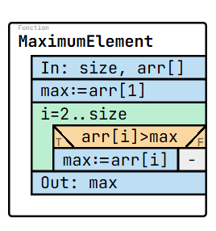
size: 5  arr: [4, 7, 2, 9, 5]  max: 9 | size: 4  arr: [-3, -8, -2, -10]  max: -2 | size: 1  arr: [12]  max: 12 | size: 4  arr: [0, 0, 0, 0]  max: 0 | size: 4  arr: [100, 50, 200, 150]  max: 200
Test cases:

Code:
1  2  3  4  5  6  7  8  9  10  11  12  13  14  15  16  17  18  19  20  21  22  23  24  25  26  27  28  29 | namespace Task1  {  internal class Program  {  static void Main(string[] args)  {  Console.Write("Enter the size of the array: ");  int n = int.Parse(Console.ReadLine());  int[] numbers = new int[n];  Console.WriteLine("Enter the elements:");  for (int i = 0; i < n; i++)  {  numbers[i] = int.Parse(Console.ReadLine());  }  int max = numbers[0];  for (int i = 1; i < n; i++)  {  if (numbers[i] > max)  {  max = numbers[i];  }  }  Console.WriteLine("Maximum element: " + max);  }  }  }

Questions:
1) Which pattern is applied in this task?
Answer: Maximum selection
2) In the postcondition, what does MAX(i=1..size, arr[i]) mean?
Answer: It means the maximum value among all array elements from index 1 to size.
3) How many times will the comparison be executed if size=6?
Answer: 5
4) What is missing in the following algorithm? (What would you write instead of <?>)
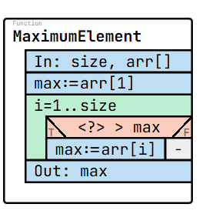
Answer: arr[i]
5) What is missing in the following specification? (What would you write instead of <?>)
In: size∈N, arr∈Z[1..size]
Out: max∈Z
Pre: size > 0
Post: (,max) = MAX(<?>)
Answer: i=1..size, arr[i]

Task 2
Problem: A bank customer recorded deposits (+) and withdrawals (-). What is the final balance change?
Pattern: Summation
Specification: (link)

In: size∈N, arr∈Z[1..size]
Out: sum∈Z
Pre: size ≥ 0
Post: sum = SUM(i=1..size, arr[i])

Algorithm: (link)
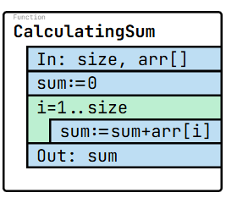
Test cases:
size: 5  arr: [1, 2, 3, 4, 5]  sum: 15 | size: 4  arr: [-1, -2, -3, -4]  sum: -10 | size: 1  arr: [10]  sum: 10 | size: 3  arr: [0, 0, 0]  sum: 0 | size: 3  arr: [100, -50, 25]  sum: 75

Code:
1  2  3  4  5  6  7  8  9  10  11  12  13  14  15  16  17  18  19  20  21  22  23  24  25  26 | namespace Task2  {  internal class Program  {  static void Main(string[] args)  {  Console.Write("Enter the size of the array: ");  int n = int.Parse(Console.ReadLine());  int[] numbers = new int[n];  Console.WriteLine("Enter the elements:");  for (int i = 0; i < n; i++)  {  numbers[i] = int.Parse(Console.ReadLine());  }  int sum = 0;  for (int i = 0; i < n; i++)  {  sum += numbers[i];  }  Console.WriteLine("Sum of elements: " + sum);  }  }  }

Questions:
1) How many additions will be made if size=8?
Answer: 8
2) Which pattern is applied in this task?
Answer: Summation
3) What is missing in the following specification? (What would you write instead of <?>)
In: size∈N, arr∈Z[1..size]
Out: sum∈Z
Pre: size ≥ 0
Post: sum = SUM(<?>)
Answer: i=1..size, arr[i]
4) What is missing in the following algorithm? (What would you write instead of <?>)
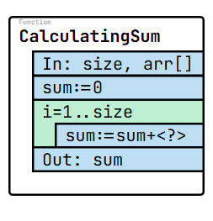
Answer: arr[i]
5) Analyze the following code that intends to calculate the sum of all elements in an array . The code compiles and runs without errors, but produces incorrect output. Identify the error and explain why it gives wrong results and on which line. (Hint: error is in lines between 7-23)
1  2  3  4  5  6  7  8  9  10  11  12  13  14  15  16  17  18  19  20  21  22  23  24  25 | namespace Task2  {  internal class Program  {  static void Main(string[] args)  {  Console.Write("Enter the size of the array: ");  int n = int.Parse(Console.ReadLine());  int[] numbers = new int[n];  Console.WriteLine("Enter the elements:");  for (int i = 0; i < n; i++)  {  numbers[i] = int.Parse(Console.ReadLine());  }  int sum = 0;  for (int i = 0; i < n; i++)  {  sum += i;  }  Console.WriteLine("Sum of elements: " + sum);  }  }  }
Answer: line 20, i is writen instead of number[i] so it calculates indexs of numbers,
not their value.

Task 3
Problem: A scientist measured water temperatures. How many were below freezing (0°C)?
Pattern: Counting

Specification: (link)

In: size∈N, arr∈Z[1..size]
Out: cnt∈N
Pre: size ≥ 0
Post: cnt = COUNT(i=1..size, (arr[i]<0))

Algorithm: (link)
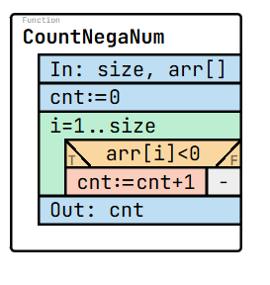
Test cases:
size: 4  arr: [-3, 7, -1, 0]  cnt: 2 | size: 4  arr: [1, 2, 3, 4]  cnt: 0 | size: 3  arr: [-5, -10, -15]  cnt: 3 | size: 1  arr: [0]  cnt: 0 | size: 5  arr: [12, -1, -4, 6, -9]  cnt: 3

Code:
1  2  3  4  5  6  7  8  9  10  11  12  13  14  15  16  17  18  19  20  21  22  23  24  25  26  27  28  29 | namespace Task3  {  internal class Program  {  static void Main(string[] args)  {  Console.Write("Enter the size of the array: ");  int n = int.Parse(Console.ReadLine());  int[] numbers = new int[n];  Console.WriteLine("Enter the elements:");  for (int i = 0; i < n; i++)  {  numbers[i] = int.Parse(Console.ReadLine());  }  int count = 0;  for (int i = 0; i < n; i++)  {  if (numbers[i] < 0)  {  count++;  }  }  Console.WriteLine("Number of negative elements: " + count);  }  }  }

Questions:
1) Which pattern is applied in this task?
Answer: Counting
2) If the array has no negative elements, what will the result be?
Answer: 0
3) What is missing in the following algorithm? (What would you write instead of <?>)
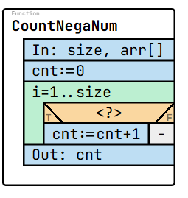
Answer: arr[i]<0
4) What is missing in the following specification? (What would you write instead of <?>)
In: size∈N, arr∈Z[1..size]
Out: cnt∈N
Pre: size ≥ 0
Post: cnt = <?>
Answer: COUNT(i=1..size, (arr[i]<0))

5) Analyze the following code that intends to calculate the sum of all elements in an array . The code compiles and runs without errors, but produces incorrect output. Identify the error and explain why it gives wrong results and on which line. (Hint: error is in lines between 7-26)

1  2  3  4  5  6  7  8  9  10  11  12  13  14  15  16  17  18  19  20  21  22  23  24  25  26  27  28  29 | namespace Task3  {  internal class Program  {  static void Main(string[] args)  {  Console.Write("Enter the size of the array: ");  int n = int.Parse(Console.ReadLine());  int[] numbers = new int[n];  Console.WriteLine("Enter the elements:");  for (int i = 0; i < n; i++)  {  numbers[i] = int.Parse(Console.ReadLine());  }  int count = 0;  for (int i = 0; i < n; i++)  {  if (numbers[i] > 0)  {  count++;  }  }  Console.WriteLine("Number of negative elements: " + count);  }  }  }

Answer: On line 20, it should be numbers[i] < 0 to count negative numbers.

Task 4
Problem: A student copied numbers from one notebook page to another. What numbers appear in the second page?
Pattern: Copy
Specification: (link)

In: size∈N, arr∈Z[1..size]
Out: cpArr∈Z[1..size]
Pre: size ≥ 0
Post: cpArr = COPY(i=1..size,arr[i])

Algorithm: (link)
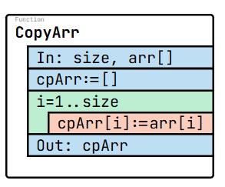
Test cases:
size: 4  arr: [1, 2, 3, 4]  cpArr: [1, 2, 3, 4] | size: 1  arr: [10]  cpArr: [10] | size: 3  arr: [-5, 0, 5]  cpArr: [-5, 0, 5] | size: 3  arr: [7, 7, 7]  cpArr: [7, 7, 7] | size: 5  arr: [2, 4, 6, 8, 10]  cpArr: [2, 4, 6, 8, 10]

Code:
1  2  3  4  5  6  7  8  9  10  11  12  13  14  15  16  17  18  19  20  21  22  23  24  25  26  27  28  29  30 | namespace Task4  {  internal class Program  {  static void Main(string[] args)  {  Console.Write("Enter the size of the array: ");  int n = int.Parse(Console.ReadLine());  int[] numbers = new int[n];  Console.WriteLine("Enter the elements:");  for (int i = 0; i < n; i++)  {  numbers[i] = int.Parse(Console.ReadLine());  }  int[] copyArray = new int[n];  for (int i = 0; i < n; i++)  {  copyArray[i] = numbers[i];  }  Console.WriteLine("Copied array elements:");  for (int i = 0; i < copyArray.Length; i++)  {  Console.Write(copyArray[i] + " ");  }  }  }  }

Questions:
1) Which pattern is applied in this task?
Answer: Copy
2) How many assignments are needed to copy size=6 elements?
Answer: 6
3) Does copying change the original array? Explain.
Answer: No, copying only makes a duplicate; the original stays the same.

4) What is missing in the following specification? (What would you write instead of <?>)
In: size∈N, arr∈Z[1..size]
Out: cpArr∈Z[1..size]
Pre: size ≥ 0
Post: cpArr = <?>
Answer: COPY(i=1..size,arr[i])
5) What is missing in the following algorithm? (What would you write instead of <?>)
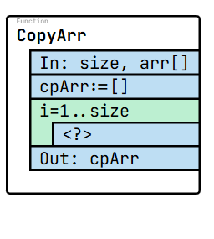
Answer: cpArr[i]:=arr[i]

Task 5
Problem: A meteorologist looks for a specific temperature value in the records.
Pattern: Search

Specification: (link)

In: size∈N, arr∈Z[1..size], target∈Z
Out: found∈L
Pre: size ≥ 0
Post: (found,) = SEARCH(i=1..size, arr[i]=target)

Algorithm: (link)
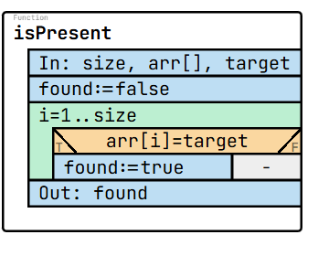
Test cases:
size: 5  arr: [4, 7, 2, 9, 5]  target: 7  found: true | size: 5  arr: [1, 2, 3, 4, 5]  target: 10  found: false | size: 1  arr: [0]  target: 0  found: true | size: 4  arr: [8, 6, 3, 1]  target: 2  found: false | size: 3  arr: [-3, -1, -7]  target: -7  found: true

1  2  3  4  5  6  7  8  9  10  11  12  13  14  15  16  17  18  19  20  21  22  23  24  25  26  27  28  29  30  31  32  33  34  35  36  37  38  39  40 | namespace Task5  {  internal class Program  {  static void Main(string[] args)  {  Console.Write("Enter the size of the array: ");  int n = int.Parse(Console.ReadLine());  int[] numbers = new int[n];  Console.WriteLine("Enter the elements:");  for (int i = 0; i < n; i++)  {  numbers[i] = int.Parse(Console.ReadLine());  }  Console.Write("Enter the target value to search: ");  int target = int.Parse(Console.ReadLine());  bool found = false;  for (int i = 0; i < n; i++)  {  if (numbers[i] == target)  {  found = true;  break;  }  }  if (found)  {  Console.WriteLine("Target " + target + " is found in the array.");  }  else  {  Console.WriteLine("Target " + target + " is not found in the array.");  }  }  }  }
Code:

Questions:
1) Which pattern is applied in this task?
Answer: Search
2) What is missing in the following specification? (What would you write instead of <?>)
In: size∈N, arr∈Z[1..size], target∈Z
Out: found∈L
Pre: size ≥ 0
Post: (found,) = SEARCH(<?>)
Answer: i=1..size, arr[i]=target
3) What is missing in the following algorithm? (What would you write instead of <?>)
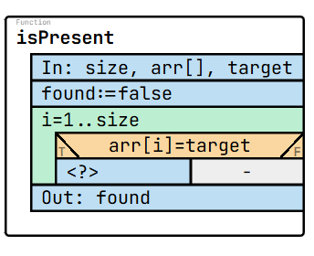
Answer: found:=true
4) If the array is empty (size=0), what happens?
Answer: The loop never runs, so found = false.

5) Analyze the following code that intends to calculate the sum of all elements in an array . The code compiles and runs without errors, but produces incorrect output. Identify the error and explain why it gives wrong results and on which line. (Hint: error is in lines between 7-26)
1  2  3  4  5  6  7  8  9  10  11  12  13  14  15  16  17  18  19  20  21  22  23  24  25  26  27  28  29  30  31  32  33  34  35  36  37  38  39  40 | namespace Task5  {  internal class Program  {  static void Main(string[] args)  {  Console.Write("Enter the size of the array: ");  int n = int.Parse(Console.ReadLine());  int[] numbers = new int[n];  Console.WriteLine("Enter the elements:");  for (int i = 0; i < n; i++)  {  numbers[i] = int.Parse(Console.ReadLine());  }  Console.Write("Enter the target value to search: ");  int target = int.Parse(Console.ReadLine());  bool found = false;  for (int i = 0; i < n; i++)  {  if (numbers[i] != target)  {  found = true;  break;  }  }  if (found)  {  Console.WriteLine("Target " + target + " is found in the array.");  }  else  {  Console.WriteLine("Target " + target + " is not found in the array.");  }  }  }  }

Answer: on line 23, Correct code is “numbers[i] == target”

